enquiries refer
Brigid Pearse
in reply please quote

23/42592
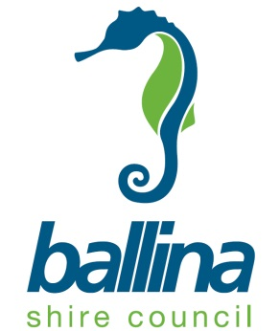
20 June 2023
Mr Jeremy Gray
Director – Northern Region
NSW Department of Planning and Environment
(Via Portal)
Attention: Ms Sandra Bush
Dear Ms Bush

Re: Request for Gateway Alteration PP- 2022- 4253 – General Housekeeping Amendments to Ballina LEP 2012

(Council ref: BSCPP 22/011)

Reference is made to the above planning proposal and the Gateway Determination dated 23 December 2022.

The Gateway Determination specifies a time frame for completing the LEP being on or before 30 June 2023. It is advised that council is unable to meet this time frame having regard to the following factor:

- Council is experiencing staff shortages. As a result Council is unable to meet the timeframe.

Having regard to the above council seeks an 8 week extension to complete the LEP with a completion date by 25 August 2023 being requested.

The project timeline below represents council’s best estimate of the likely completion time of the planning proposal.

Page 2 of 2
NSW Department of Planning and Environment
20 June 2023

Plan Making Step | Estimated Completion (Before)
Gateway Determination | 23 December 2022
Government Agency Consultation | February 2023
Public Exhibition Period | 18 January to 10 February 2023
Public Hearing | N/A
Submissions Assessment | March – April 2023
LPMA Assessment of Planning Proposal and Exhibition Outcomes | May 2023
LPMA Decision to Make the LEP Amendment | May 2023
Forwarding of LEP Amendment to DPE for Notification | August 2023

If you have any enquiries in regard to this matter, please contact Brigid Pearse on 02 66810571 or via email Brigid.pearse@ballina.nsw.gov.au , please note my work days are Tuesdays and Wednesdays.

Yours faithfully

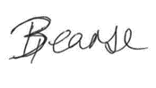

Brigid Pearse

Strategic Planner

Planning and Environmental Health Division

